**学习卡1**

**1.小组活动要求：**

**(1)小组内选出一张学习卡。**

**(2)画出对称轴，选出两组对称点用线段连接起来。**

**(3)看一看，数一数，你发现了什么？**

**(4)把你们的发现记录下来。**

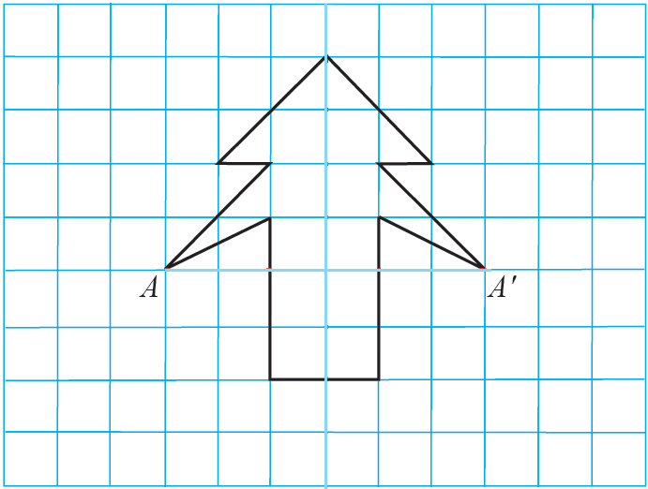

**我们的发现：**

**学习卡2**

**2.你能把这个轴对称图形的另一半补全吗？**

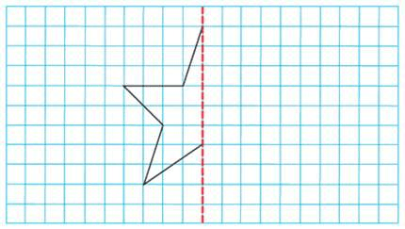

**3. 请你在方格图上设计一幅简单而美丽的轴对称图形。**

|  |  |  |  |  |  |  |  |  |  |
| --- | --- | --- | --- | --- | --- | --- | --- | --- | --- |
|  |  |  |  |  |  |  |  |  |  |
|  |  |  |  |  |  |  |  |  |  |
|  |  |  |  |  |  |  |  |  |  |
|  |  |  |  |  |  |  |  |  |  |
|  |  |  |  |  |  |  |  |  |  |
|  |  |  |  |  |  |  |  |  |  |
|  |  |  |  |  |  |  |  |  |  |
|  |  |  |  |  |  |  |  |  |  |
|  |  |  |  |  |  |  |  |  |  |