Lesson4 Sally is going to Beijing.
第二课时
梧州市新兴二路小学 曾慧
一、教学目标
（一）知识目标
1. 能够听懂、会说、认读句子“ Harbin is in the north of China. Do you want
to see an Ice palace Go to Harbin s Ice and Snow Festival. The blue sky, green grass and white sheep make Xinjiang beautiful. People in Xinjiang like singing and dancing. There is no winter In Hainan. You can enjoy beautiful beaches all year round. You can also eat many kinds of fruits there.”
2. 初步了解字母组合ts和ds在单词中的发音
（二）能力目标
1. 能听懂配图小故事，能借助图片理解故事，能够正确朗读所学文本。
2. 能够根据图片内容用 be going to结构书写句子
3. 能运用 be going to结构描述将要发生的事情，并具有一定的语篇表达能力
（三）情感态度、文化意识、学习策略。
1. 能积极参加语言学习活动，在情景表演活动中形成运用语言的能力。
2. 通过了解中国的风景名胜。
3. 能合理规划自己的假期生活。
二、教学重难点
（一）教学重点
能在图片的帮助下理解故事，并能够朗读故事。
（二）教学难点
能综合运用所学的语言，描述某旅游景点的特点。
三、教学准备
课本、单词卡、课件等。
四、教学过程
Step1 Warm up
- Greetings
- Free talk
T: May Day is coming. Do you like traveling? Where do you want to go? Why?
Step2 Presentation
1. Leading 课件呈现一份旅游日报，并提出问题“What can you see?”学生整体感知课文内容。
2. Listen and circle “Where is Harbin? What's the weather like in Harbin? ”从这两个问题引出哈尔滨的冰雕节。
3. Read and answer 教师通过引导学生看图并提出问题(1) Where is Xinjiang? (2) Is Xinjiang beautiful? (3) What do people like in Xinjiang? (4) What's the weather like in Hainan? (5) What can we eat in Hainan?让学生了解新疆和海南的地理位置和其他方面的知识。
4. Read and tick 学生再次阅读文本并完成课本上的表格。
5.Listen and repeat学生再次听录音，跟读，模仿。
Step3 Practice
- Fill in the blanks
Harbin is in the ______ of China. It's very cold in winter there. We can see an
___________. It's wonderful.
Xinjiang is in the ______ of China. The blue ____, green ______ and white
______make Xinjiang beautiful. People in Xinjiang like ________ and _________.
There is no _______ in Hainan. You can enjoy beautiful _______ all year round.
You can also eat many kinds of _______ there.
Step4 Cosolidation
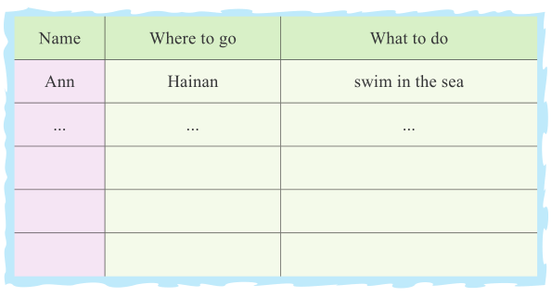
- Make a survey：Talk with your partners and try to fill the blanks. “Where are
you going? What are you going to do there?”

- Emotion Education：To be a civilized traveler!
Step5 Pronunciation
- Listen to the words课件呈现单词，学生听音感知字母组合的发音规律。
- Let’s talk more words with ts or ds.
Step6 Homework
Make a plan for the next holiday.
五、板书设计
Lesson 4 Sally is going to Beijing.

Places | Views
Harbin | an ice palace
Xinjiang | blue sky, green grass and white sheep
Hainan | Beautiful beaches

