PEP四年级下册Unit 6 Shopping
广西河池市大化县江南乡中心小学 韦初彬
455794498@qq.com 18378889460
Teaching contents: Part B Let's tall
The analysis of teaching content:
It's go on with the Unit5. And it is closely related to student's life. It includes 2 parts: let’s talk and let’s learn. In let’s learn, it mainly deals with these key words: nice, pretty, cheap, expensive. And in let’s talk, it deals with the patterns: how much is the dress? How do you like this skirt? It’s too expensive. I will take it.
Analysis of the students:
Our students are in Grade 4.They are active and curious, interested in new things.After learning English for 2years, they have some basic English background knowledge.
Teaching aims:
① The first one is language knowledge.
By the end of the lesson, students will be able to read, recognize, and use these words and these sentences.
② The second one is language skills.
By the end of the lesson, students can use the sentence pattern of inquiring the price and express their thoughts in the proper scene.
③ The third one is emotional aim.
In this lesson, the emotional aim are to help students cultivate and foster their abilities of working in groups and solve problems independently..
Teaching focus:
A) to make sure that Ss can use the new words and sentences correctly and skillfully.
B) to develop Ss’interest in English.
Teaching difficulty:
The Ss can use the words and patterns to describe the clothes and price in the proper scene, and make simple dialogues of shopping.
Teaching methods:
In this lesson, teacher will mainly use “Task-based teaching method”, “Communicative language teaching method” and so on.
Teaching aids:
computer multimedia
Teaching procedure:
Step 1. Greeting and Warming-up
- Greetings
Teacher say hello to Ss.
- Free talk
T: What’s the weather like today? Can I wear my gloves/coat/shirt?
Ss: Yes/No.
- Sing a song “How much is it?”.
Step 2. Revision and Presentation
1.Review the words and useful sentences about clothes.
Teacher shows the picture and say : Sarah and her mum will go shopping now.Can you guess :What’s in the shop?
T:let’s go into the shop and have a look. T:There are so many clothes in this shop. What’s this? What are these?
Ss:dress,shirt,socks,shoes...
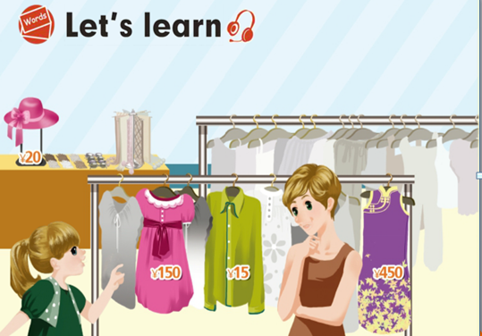
T: Look at that dress. How do you like the ....? Is it ....?
Ss:Yes, it is./ No, it isn’t.
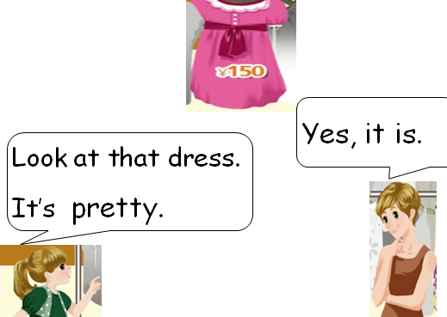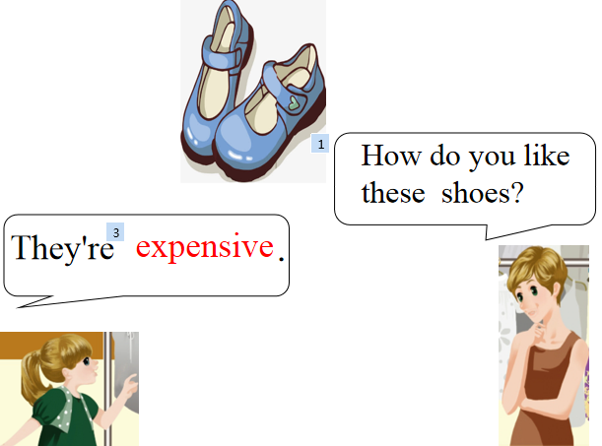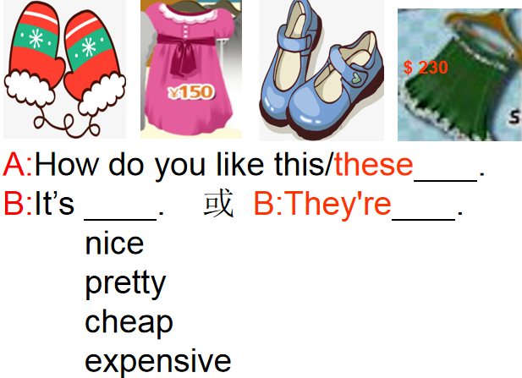
Then teacher shows the pictures and asks the Ss one by one. And Ss answer by the adjectives words.
- At this time, play the video . Let my students learn synchronously with the teachers in the video. Let the students concentrate on watching and listening. (视频资源来自双师教学资源网站）
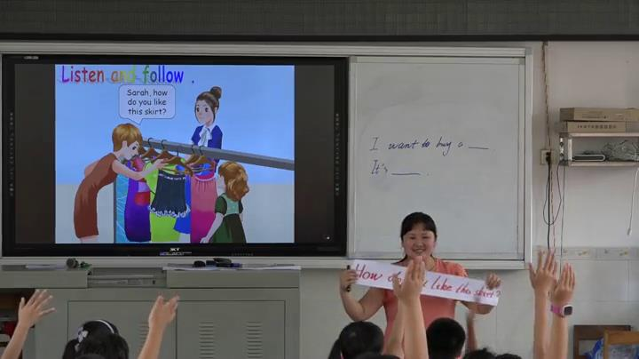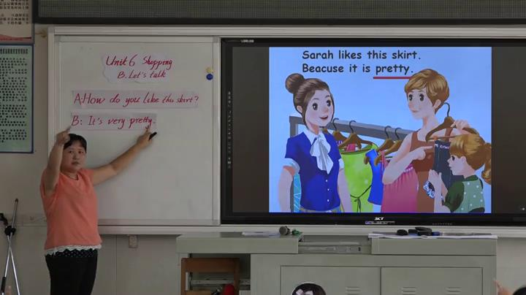
Then, ask the students to answer the questions in the video.Students are expected to answer some questions related to the new words. In this way, new words are revised.
Meanwhile, teacher will write down the sentence patterns on the blackboard. Students need to practice the new words and sentences in different ways.
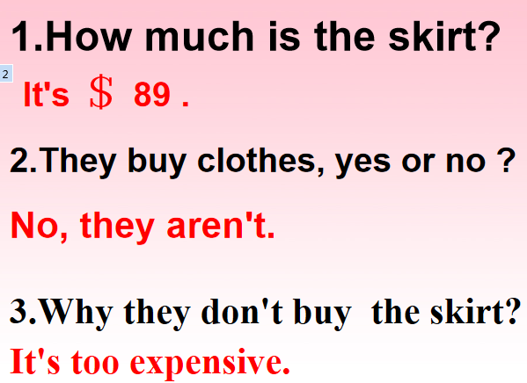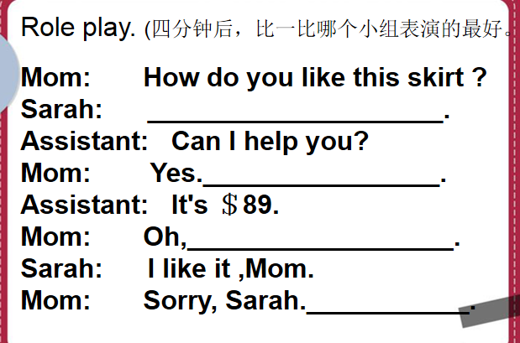
Step3. Practice
- Act: let Ss try to act out the dialogue.
- Let Ss do more practices.
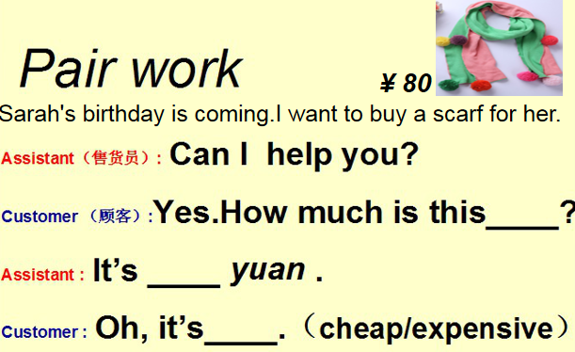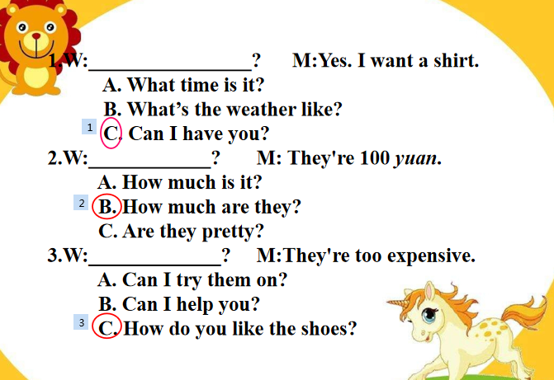
Step 4. Development
Task: Father’s Day.
In advance, teacher shall arrange the classroom to some business locations, such as clothes store, shoes store, fruit store etc. And divide the class into groups and play roles, and then give the Ss a certain lots of specie currency, so that they may choose and buy the gifts for mother’s Day.
For this step, teacher shall instruct the Ss to use the words and patterns learn in the process of completing certain tasks. Meanwhile, they may have mutual improvement in exchanging information during the communicating activities.
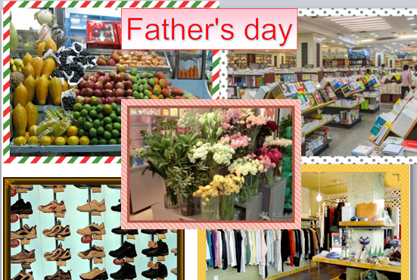
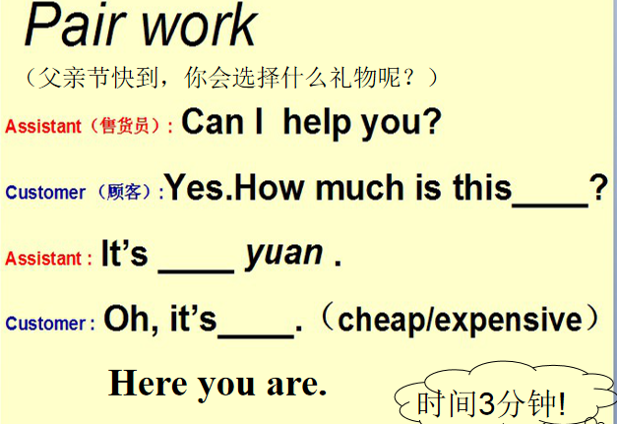
Step 5. Conclusion and Extension
In this step, teacher will guide the Ss to conclude the key words and sentences. And also, teacher will also leads to the emotion objective of this lesson, that is to have moral education in this step. Good to know: 理性购物，不盲目选择贵的商品。
Homework:
1.Listen and repeat, then imitate.
2.Act the dialogue in groups.
Blackboard design:
