课题：Amy’s Summer Holiday’s Plan
教学目标：
一、语言知识：
1.复习词汇：有关假期活动的词组，如：go shopping 等。
2.复习句子：(1)Where are going on your holiday?
(2)Who are you going with?
(3)What are you going to do there?
(4)How do you going there?
3.复习一般将来时用法、句型、时间状语并能完成相关练习。
二、语言技能：
能够借助思维导图复述Amy’s Summer Holiday’s Plan。
三、学习策略：
1.以小组合作学习的方式引导学生归纳有关假期活动的词组等。
2.学生能够通过阅读对话文本提取相关信息。
3.能够熟练掌握一些练习的答题技巧。
四、情感态度：
学生能够对英语课堂活动感兴趣，积极参与各项活动。
Step 1 Warm-up
1.Greetings.
2.Look and guess.
T:let’s play a game. Look and geuss. Think of a word.(利用微视频呈现度假图片和提示语言：We don’t go to school. We can take a trip . We can go swimming .We can go fishing. We can go camping.以及_ _ _ _ _ _ _提示学生该单词由其个字母构成。引导学生通过图片和文字的提示猜词，以激发学生的学习兴趣，导入本课的学习的主题holiday。)
3. Brainstorm
教师请学生拿出课前完成的“复习先学表”，在小组内分享假期能做的事情。
4.教师利用PPT呈现相关的动词短语和图片，做配对游戏。男生女生各派一个代表，以记时的方式分胜负。
（游戏规则：以计时的方式分胜负。选手把词组放到短语中，对的话，该组员说，Yes,再把读该短语两遍，读完了再配对方下一幅图，反之说，No.继续配对，以此类推。）
4.Group the verbal phrases.
5.T:There are so many phrases to remember. It’s not easy, right? How can we do? OK, we can group them like this.（教师给一个例子给学生参考）
After class, please try to use this way to remember the phrases.
a trip
take
pictures
Step2 presentation
1.Get to know Amy’s summer holiday’s plan.
(1)Listen and answer.
Where is Amy going on her summer holiday?（点名回答）
(2).Read and complete the mind map.

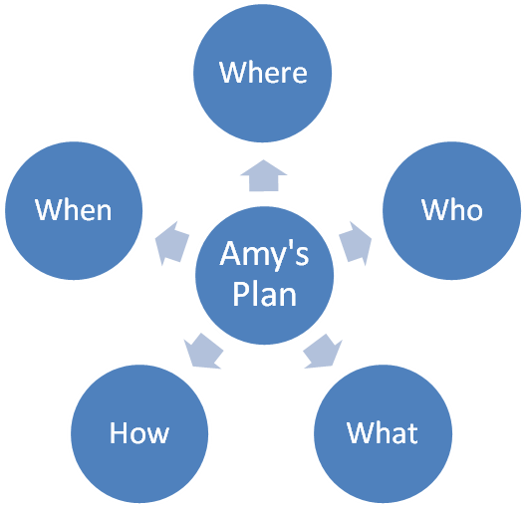

(3)Read the dialogue together and check the answers.
(4)According the mind map to retell the conversation in gruops.
The summer holiday is coming. Amy is going to _____. She is going with her______. She is going to________ and ____________.They are going by_______.
(5)Sum up the language form in gruops.
(6)Say out（点名提问，同时板书）
(7)呈现be的顺口溜，帮助学生记忆。
Step 3Do some exercises.（一题一题呈现答题，学生自己讲解）
Step 4 Summary
Step5 Homework

板书设计
Amy’s Summer Holiday’s Plan

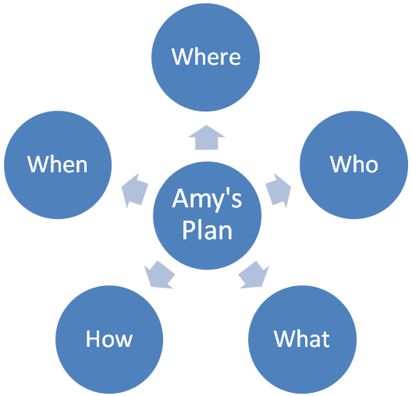

主语+be going to+
We （动词原形）
I
He
She
It
They
John

附件1
复习先学表
班别： 姓名：
Task1 请把你认为假期可以做的事写下来：
We can

Task2 请你把我们学过的有关乘坐某种交通工具的短语写下来：

Task3 请你填一填。
1.一般将来时表示

2.一般将来时的句子结构：

3.常用来表示将来的时间状语：

组长评分：
附件2

课堂练习
班别： 姓名： 组长评分：
一、阅读对话，完成思维导图。

文本：
Chen Jie: Hello.
Amy: Hello.
Chen Jie: The summer holiday is coming. Where are you going on your holiday?
Amy: I am going to Sanya.
Chen Jie: Great.Who are you going with?
Amy: My parents.
Chen Jie: What are you going to do?
Amy: We are going to go swimming in the sea.
Chen Jie: What else are you going to do?
Amy: I am going to take some pictures of my parents.
Chen Jie: Sounds great.How are you going there?
Amy: We are going by plane.
Chen Jie: Have a good time.
Amy: Thank you.
二、单项选择题。
1.We going to Hainan this summer holiday.
A. am B. are C. is
2.John is going to basketball this afternoon.
A. play B. plays C. playing
三、答语配对。
I
( )1.Where are you going this weekend?
( )2.What are you going to do there?
( )3.When is Daming going to Guilin?
( )4.Who are you going with?
( )5.How is ChenJie going there?
II
A. Next week.
B. My parents.
C. I’m going to the park.
D. She is going by bus.
E. I’m going to visit my grandparents.
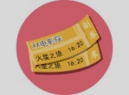
四、仿写句子。
例：I, see a film, tonight
I am going to see a film tonight.
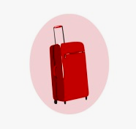
1. Lily, take a trip ,next week
____________________________________________


2. we, go to the supermarket, this evening
____________________________________________

