A lesson Planing of Unit 1 Can you play the guitar ?
(The First Period)
Teaching Topic | Unit1 Can you play the guitar?  The first period(1a - 1c)
Class Type | Listening and Speaking Course | Place | Classroom
Teaching philosophy | English teaching is a kind of dynamic or activity teaching, which the process is a communicative activity. When in teaching, I begin a class with the organization of teaching activities and design a lot of language practice. Only in this way can I make the class communication. One of the major purposes of the teaching is to cultivate students’ communicative competence in English. New Curriculum points out that foreign language teaching should develop competence-based objectives, and allow flexibility and adaptability. We also have to cultivate students’ basic skills, which are included listening, reading, speaking and writing.
Analysis of the Teaching Material | The content of my lesson is unit 1.This unit is about what can you do. By studying this unit we’ll enable students to know what one is skilled in. At the same time, let the students learn how to make talk about his or her skills. It also can help students to attain “four skills” request of listening, speaking, reading and writing. Therefore, this lesson is in the position of this unit. If students can master it well, it can be helpful for them understand the whole passage.
Analysis of the students | Most students are interested in talk about his or her skills. So this topic can greatly attract their interests. It can accelerate them to learn English and know about each other. After learning this lesson, they will know about what can they do.
Teaching objects | - Knowledge object  To master the key words: guitar, sing, swim, dance, chess, play chess, draw, speak, speak English, join, club.  (2)Ability object  To develop the Student’s abilities of listening, speaking, reading and writing.  - Emotional object  By completing the task, students can know about each other well.
Teaching key points | 1 To help students master the useful phrase.  ① —Can you play the guitar? —Yes, I can./ No, I can't.  2 To help students ask and talk about their abilities.
Teaching difficult points | Students understand the Composition and Use of Modal Verb Can.
Teaching Methods | Task-based Language Teaching
Learning strategies | Learner autonomy and cooperative learning
Teaching Aids | Multimedia
Teaching Procedure | Step 1 Warming-up and leading-in  - Greeting.  2. Watching the video and then guess what kinds of musical instruments you have heard in the video.  (Justification: attract student’s attention to learn this topic)  Step2 Presentation  - New words: guitar, sing, swim, dance, chess, play chess, draw, speak, speak English, join, club.  T: read the new words.  Students: read the words follow the teachers  T: Ask two students to act a little teacher to teach the new words.  Students: read them.  - Writing  T: Ask four students to write down the words from memory on the blackboard.  Then Check the answers with the class together.  4.Learning the Verb phrases : I can dance／swim／sing／"··But I can’t dance／swim／sing so on.  5.Students look at the picture in 1a. Then read the words and phrases. Let Students match the activities with the people.  T: Ask students to answer the question in 1a.  Then Check the answers with the class together.  Step3 Looking and reading  - T: Tell the students what dose he do. For example: Look the picture ,what does the do ? He sings a song. Can you sing? Yes, I can. ／ No, I can. ／ I want to join the music club.  Look the next pictures.  T:Ask some students to answer my questions. For example:Can you dance? Yes, I can. ／ No, I can.／ I want to join ....  - Game  T: Show some picture in PPT, let the students guess and read.  Students: Practice the next picture follow the example.  (Justification: let student’s master the languages of the topic)  Step4 Pair work  - Ask the Students to practice the words and conversations with a partner. Then make their own conversations.  - Interviewing (In groups, discuss the following question: what can you do ? I can ... but I can’t...  (Justification: to make the student master the useful phrases and develop students’ writing ability .)  Step5 Listening  1. T: Now let’s listen to the tape, find out the right conversation, and number them 1-3.  2. Listen again and answer the questions  Step5 Pair work  1. Ask the Students to practice the conversations in 1b with a partner. Then make their own conversations.  Step6 Exercises
Summary and homework | Summary: Ask one student to act as an assistant teacher to guide others to summarize what they have learned in this class. And then give a conclusion about this lesson.  Homework:  Make a survey  A: What club do you want to join? B: I want to join the music club.  A: What can you do? B: I can…  A: Can you sing well? B: Yes, I can./ No, I can’t.  (Justification: homework is so important and necessary for students to master the knowledge they have learned in class. It will check whether the students achieve the teaching aims.)
  Name | Can | Club (want to join)
Blackboard design | Unit1 Can you play the guitar?  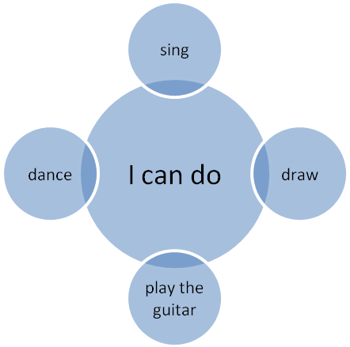  Function items: talking about the abilities
Reflection | The whole lesson I run through the new curriculum concept, promote learner-centredness and respect individual differences. let them have a chance to get to know about each other. Therefore, in English teaching, teacher should create good condition and good environment and let the students take part in the whole class activities. In this class, I do well in making students practice more. Let the students study each other. And let the students study independently. I do not well in making students learn and expend more knowledge. But I also want to appreciate my students because I get the confidence from their face.so in the future and I will try my best to improve my teaching skills.

